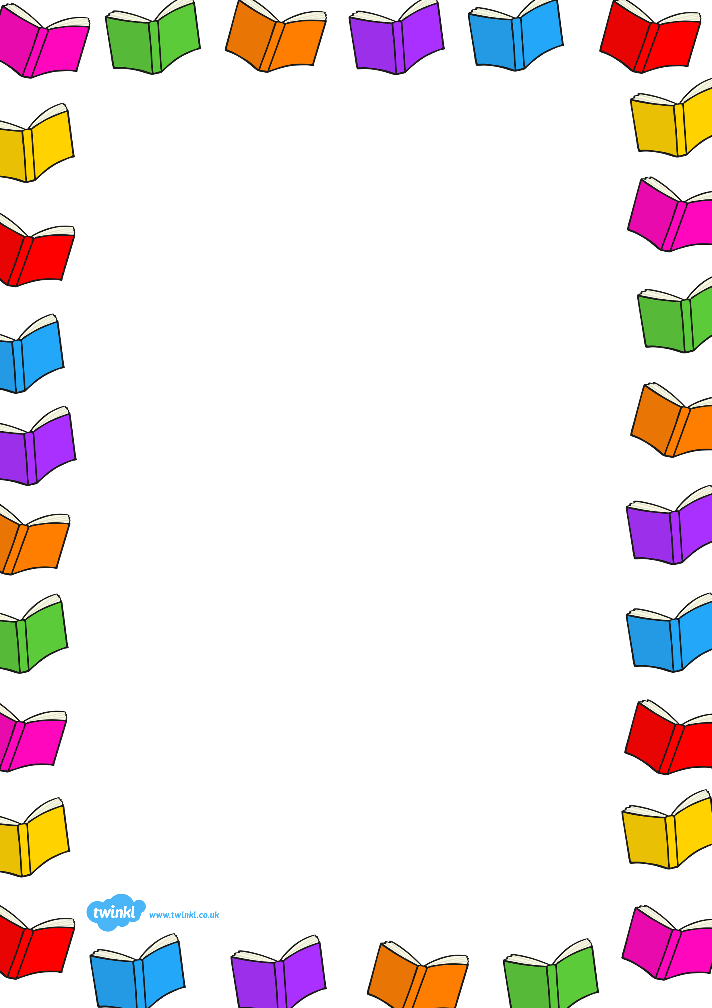

Book Week Scotland takes place W/C 18th November and as usual we are extending ours to a Book fortnight so we can fit in lots of fabulous activities.
There will be book week activities during Breakfast Club
We will be gifting our P1 Bookbug and P2/3 Read Write Count Bags at Celebration parties (invitations will be sent to Parents/Carers to join us in school ☺) Please post any other Reading related activities on Seesaw.
P4-7 have a Book photo challenge to complete and can share their Reading experiences on their TEAMS pages as well as participating in some book related fun in class.
Each class will be decorating their door as a book front cover. We will be sharing them with Parents/Carers and inviting them to vote on their favourite.
Family Challenge- Share a photo of you reading a story together on Seesaw/Teams/Twitter @HarrysmuirPS
House points will be awarded for all photos and there will be star tokens for the most interesting places you are reading ☺
Happy Reading! #HarrysmuirReads

